|  |
| --- |
|  |



**28 September 2012** **The Weekly Bulletin of Rotary Club of Kathmandu Mid-Town** **Bc-28.9/012-13**

District : 3292 Web:www.rotarymidtown.org.np Club Id : 26776

**SEPTEMBER IS THE NEW GENERATIONS MONTH**

September is New Generations Month. We could just as well call September “***the month of our future***” because investing in our youth is our future. We can take pride in the fact that we have youth programs for just about every age group with Rotarians serving as active, caring sponsors.

Friday, 21 September:

Guest Speaker Binod Shahi, at the start, presented a brief video presentation on Dolpo and his school project. He spoke about his experience and mission. He explained the spirit in which he carried on his project to run a small school in the premises of the local monastery. He criticized the culture of seeking donor support even for small project. He sought to demonstrate that the locals and with the support of compatriots can do a lot of things themselves. He wanted to teach them the culture of self-reliance. At present, three or four teachers are volunteering to run the school. Although it is recognized by government, designated teachers appear in the village only occasionally just for a visit and collect salaries.

He needs about Rs 5 lakh to run the school for one year. Most money is spent in transportation. Villagers provide food and Yeti Airlines provide transport support. He thinks Rotary support could be instrumental in medicinal and other support. He does not want to use foreign money for his school as he would like to set an example that the locals are capable of doing it themselves.

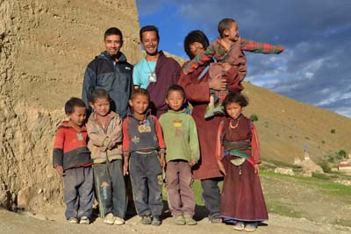 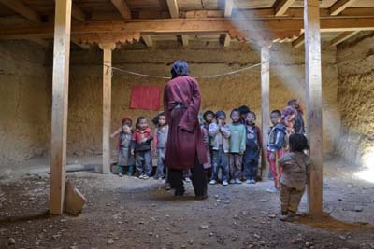

Binod Shahi with his students & Rtn Rabi Binod in his School session

*Photos courtesy:* Rtn Rabi Karmacharya

# Weekly Meetings and Programs :

|  |  |  |
| --- | --- | --- |
| Date | Program/Speaker | Program/Topics of Presentation |
| 28 Sep 2012 | DG Visit | Dinner meeting |
| 5 Oct 2012 | US Ambassador Peter Bodde | Where I have been since last seeing you all……. |
| 12 Oct 2012 | Catherine Jenson, Sheer Memorial Hospital | My work at Sheer Memorial Hospital |
|  |  |  |

Friday, 28 September:

Dinner meeting: DG Visit

IPP Som appointed as the contact:

RC Boeblingen Schoenbuch transferred fund amounting to Euro 5,822 for PA Nepal Children House, Sankhu project. President Devendra appointed IPP Som as the contact person for this project.

New Generation: Trustees of our Nation!

**R.I.D. Shekhar Mehta**

Shekhar Mehta.bmp

A morning look at the newspaper does not always make you feel very happy about the state of

things in our country. Corruption, rapes, killing stare at you from the newspaper which is actually the reflection of our times and state of affairs. Reasons enough to make your day start on a gloomy note. So do only dark clouds envelop us? No, there is a Silver lining and it is in the form of New Generations. They are the trustees of our nation and of our posterity. More I look at them the greater hope I have for the future of our country. These are better educated, more knowledgeable, more honest people. They are our future, they are our tomorrow. Working with the New Generations and for the New Generations therefore is one of the most fruitful ways of service in Rotary

At the Literacy Conference in Kathmandu we had set ourselves a target for Total Literacy by 2017. The time has now come to act on it. If we want the nation to be strong and educated we will have to first and foremost literate and then educate our youth. Mere literacy will not help. Education is what we need to provide because that is the birth right of every citizen of our country. The time has now come to put our thoughts on Literacy into action. For a national program on Literacy we have divided the program in 3 parts – Child Development, School Development and e-learning.

If you truly want to serve the new generations of our country the beginning will have to be made by ensuring that the new generation is educated.

*source:* Samanwoya: e-Bulletin of Rotary Coordinator, zone 4 & 6A, September 2012 *courtesy:* PDG Tirtha Man Sakya

New Generations: Shaping Youth

It is well said, we cannot build future for youth but we can build youth for future. Rotary believes in this philosophy in words and spirits. And so one entire avenue ‘New generation’ stresses upon youth. Various programs through this avenue are particularly designed to shape youth for future. Rotaract, Interact, Rotary Youth Exchange, RYLA, all these programs help young people to develop as better citizens and better leaders of tomorrow, to better understand their responsibilities towards communities they belong. Good individuals make a good society and good societies make a good nation. Entire young generation of healthy bodies and healthy minds shall make a healthy and strong nation.

Rotary’s future is linked to world’s future and world’s future is linked to today’s youth. World’s oldest and first voluntary organization is aging and IPRIP Kalyan Banerjee‘s emphasis upon ‘graying to greening’ should be of top priority for Rotary as Rotary firmly believes that if Rotary has to survive and grow in this century, it must be made attractive to young people. And so it underlines why Rotary is focusing to shape the younger generation for better future.

*source:* PDG Shrirang Prabhu / Samanwoya: e-Bulletin of Rotary Coordinator, zone 4 & 6A, September 2012

Clubs that welcome kids can boost membership and service

Clubs are not always so accommodating. In an online forum in 2009, Genevieve Flight, now a member of the Rotary Club of London, reported that at her previous club, she was reprimanded after she brought her three-year-old to a meeting. A club officer warned her never to bring her son again. In the same post, she suggested that Rotary International do more to encourage clubs to welcome Rotarians with children. “This is the best way forward towards getting more younger members into Rotary,” she wrote.

Many others have worked to make Rotary more appealing to tot-toting families like mine. Those family-friendly clubs have reported success in gaining new members and keeping those they might otherwise have lost.

Here are some tips from parents and clubs who are making Rotary a family affair:

**Just bring ’em:** “You’re bringing them everywhere else. Why aren’t you bringing them here?” says Christine Byrne, past president of the Rotary Club of Casco Bay-Sunrise (Portland Area), Maine. Though she acknowledges that some clubs are more child friendly than others, Byrne says people with kids in tow will feel less self-conscious if they remember that they’re not the only parents in the room.

**Hire help:** The Rotary Club of Fremont (Seattle), Wash., hired a sitter to help at its evening meetings at Hale’s Ales. Parents and grandparents pay $5 per child, and the half-dozen or so kids have a room of their own. At the start of each meeting, the children lead the Pledge of Allegiance. At the end, they ring the bell. In between, they retreat to watch movies, color, and eat dinner; they also may choose to eat with the adults. Once a month, the kids help make sandwiches for a local homeless shelter. “It’s a meeting for them too,” says club member Shoshanna Osterfeld, whose children are four and six. “They get together. They talk about their week. It’s a wonderful experience.”

**Think younger:** Another key to the club’s success is child-oriented projects. Several times a year, the Rotarians and their families take a walk along a local bike path, picking up trash as they go. Last year, they installed swings for children with special needs at area playgrounds. In July, they held a “Gymathon” event, raising money for a Seattle school through sponsored workouts.

**Take a little vacation:** District 7600 (Virginia) hopes to attract Rotary families to its October conference by holding it at a ski resort. “This is going to be the first time we’re having a conference that’s really promoting bringing children and grandchildren,” says Past District Governor Bill Pollard, who has an 11-year-old daughter. “We’re getting younger people involved in more leadership positions, and they don’t want to leave their families all the time for Rotary.”

**Take a big vacation:** Marycris Oplas, of the Rotary Club of Makati Urdaneta, Philippines, brought her children to the Salt Lake City convention in 2007, when they were seven and nine . She and her husband, Donnies Alas, of the Rotary Club of Makati North, felt as if they were the only family with small children in tow. Even so, she says, “it was a good experience for the kids.” Now 12 and 14, they have come to expect that their family vacations will coincide with Rotary conventions.

**Assign homework:** Eleven-year-old Samantha Pierce has logged five international conventions. Her mom, Candy Pierce, of the Rotary Club of Cordelia, Calif., pulled her out of school to go to the 2011 convention in New Orleans, but gave her an assignment: Meet someone and learn about that person’s country. Samantha spent three days interviewing and photographing some new friends at the Safe Blood Africa booth. “She had the time of her life,” Pierce says, and Samantha returned to school with a detailed report on Nigeria.

**Take the long view:** Samantha started going to club meetings as an infant. As she got older, she started helping out at fundraisers, and she attended many Rotary events when her mother was governor of District 5160. It wasn’t always an easy balance, but to Pierce, the benefits are clear. “She has no qualms about walking up to an adult and having a conversation with them, and I think it’s mostly because of Rotary,” she says.

*Source:* Kim Lisagor, *The Rotarian - September 2012* /Rotary International News

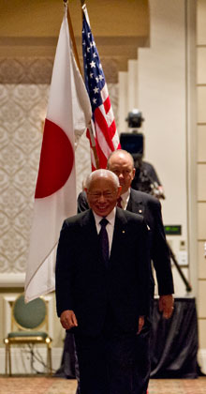

We must remember that the youth of today are the leaders of tomorrow. By helping to develop

young leaders and bringing younger members into our clubs, we strengthen communities – and

Rotary’s future..

**RI President Sakuji Tanaka**

**AN IRISH  FRIENDSHIP WISH for the day:**

**May there always be work for your hands to do;**

**May your purse always hold a coin or two;**

**May the sun always shine on your windowpane;**

**May a rainbow be certain to follow each rain;**

**May the hand of a friend always be near you;**

**May God fill your heart with gladness to cheer you.**

*courtesy:* Rtn Dr Isabella C Bassingana Khadka

 .

On Lighter Side :

Click here ⇩



**Can you read this in first attempt?**



If you can, you have good eyes!

NB: If you have any information/photo that may be of interest to Rotarians send them to

BC Editor: RR Shrestha email: rryesrr@gmail.com

## 28 Sept 2012 The Weekly Bulletin of Rotary Club of Kathmandu Mid-Town bc-28.9/012-13